Direct Marketing using Logistic regression

P.Madan [D18015]
Praxis Business School
Banglore, India

Md. Saheer [D18019]
Praxis Business School
Banglore, India

Abstract—The aim of this paper is to show how logistic regression was used to find the best set of customers from the marketing dataset so that these set of customers alone can be targeted in a marketing campaign.

Introduction
Linear regression works well when the target column we are trying to predict, the dependent variable, is ordered and continuous. If the target column instead contains discrete values, then linear regression isn't a good fit.
In this paper, we'll explore how to build a predictive model for these types of problems, which are known as classification problems. In classification, our target column has a finite set of possible values which represent different categories a row can belong to. We use integers to represent the different categories so we can continue to use mathematical functions to describe how the independent variables map to the dependent variable.

Table 1
Problem | Sample Features | Type | Categories | Numerical Categories
To predict whether a customer will purchase or not | Age,  gender,  Own home,  Married,  Location Salary,  Children and Catalogs | Binary | Purchase,  Not purchased | 0,1

Let us understand the data for this problem with Table 1
We'll be working with a dataset containing data on 1000 customers with the following columns:
- Age – Customer’s Age. Contains three categories Middle, Old and Young
- Gender – Customer’s Sex. Male or Female
- Own Home – Customer’s living Place. Owned or Rent
- Married – Customer’s Marital Status. Married or Single
- Location – Distance of the customer from the Store. Far and Close
- Salary – Customer earnings. Ranges From 10100 to 168800
- Children – Count of the customers children. Ranges from 0 to 3
- Catalogs – Number of Catalogs customer owns.6,12,18 and 24
- Purchase – Customer has purchased or not.1 or 0(Target Variable)

First Four rows of the dataset:
Age | Gender | Own Home | Married | Location | Salary
Old | Female | Own | Single | Far | 47500
Middle | Male | Rent | Single | Close | 63600
Young | Female | Rent | Single | Close | 13500
Middle | Male | Own | Married | Close | 85600

Children | Catalogues | Purchase
0 | 6 | 47500
0 | 6 | 63600
0 | 18 | 13500
1 | 18 | 85600

When numbers are used to represent different options or categories, they are referred to as categorical values. Classification focuses on estimating the relationship between the independent variables and the dependent, categorical variable.
In this paper, we'll focus on a classification technique called logistic regression. While a linear regression model outputs a real number as the label, a logistic regression model outputs a probability value. In binary classification, if the probability value is larger than a certain threshold probability, we assign the label for that row 1 or 0 otherwise.
In linear regression, we used the linear function y = mx + b to represent the relationship between the independent variables and the dependent variable. In logistic regression, we use the logistic function, which is a version of the linear function that is adapted for classification.
Unlike in linear regression, where the output can be any real value, in logistic regression the output has to be a real value between 0 and 1, since the output represents a probability value.
Note: The model can't output a negative value or it would violate this criteria.
Here's the mathematical representation of the logistic function:
σ (t) = e^{t} / ( 1 + e^{t} )
The logistic function is broken up into 2 key parts:
- The exponential transformation, transforming all values to be positive: e^{t}
- The normalization transformation, transforming all values to range between 0 and 1: t/1+t

The exponential transformation and the normalization forces the output values to be squeezed between 0and 1. If you plot just the exponential part, the output values won't be limited to the range of 0 to 1:

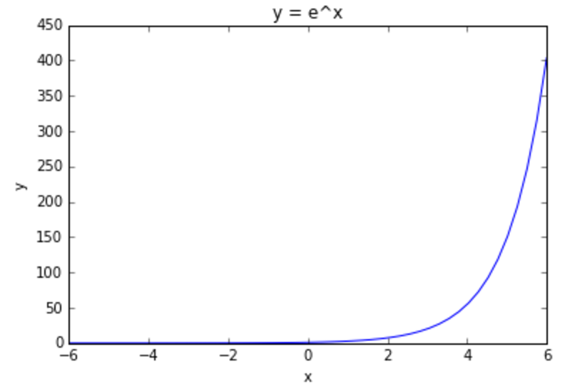

The normalization part alone unfortunately isn't sufficient since it struggles at constraining negative values:
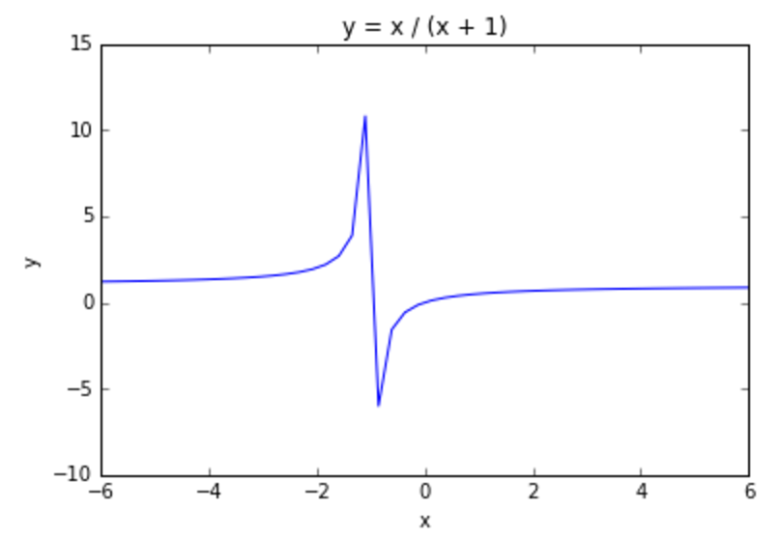
Together, both of these pieces work well to constrain the output to the range of values that probabilities are in.
Odds Ratio:
Odds ratio indicates that how much more likely it is that an event occurred compared to it is not occurring.
π(1) / 1 – π(1) = e^{b0 + b1} ---------- [1]
π(0) / 1 – π(0) = e^{b0} ---------- [2]
Odds ratio = [1] / [2] = e^{b1} ---------- [3]

To put the Odds ratio into use we take a natural log of it, to get the logistic regression coefficient of a particular variable.
ln ( e^{b1} ) = b1
Interpreting the logistic regression coefficient for a continuous predictor:
For a constant c, the quantity c (b1) represents the estimated change in log Odds ratio, for an increase of c units the predictor.
Maximum Like hood Estimation:
- There is no closed form solution exists for estimating logistic regression coefficients, but the cost function is concave, so Gradient ascent (or any other optimization algorithm) is guaranteed to find the global maximum.
- MLE, which finds estimates of parameters for which the likelihood of observing the observed data is maximized.

Likelihood function l(B|x) is function of parameters B=b0 + b1 +…. +bn which express probability of observed data. Find values of B which maximize l(B|x), uncovering MLE, the parameter values most favored by the observed data.
Cost ( h_{θ}(x) , y ) = 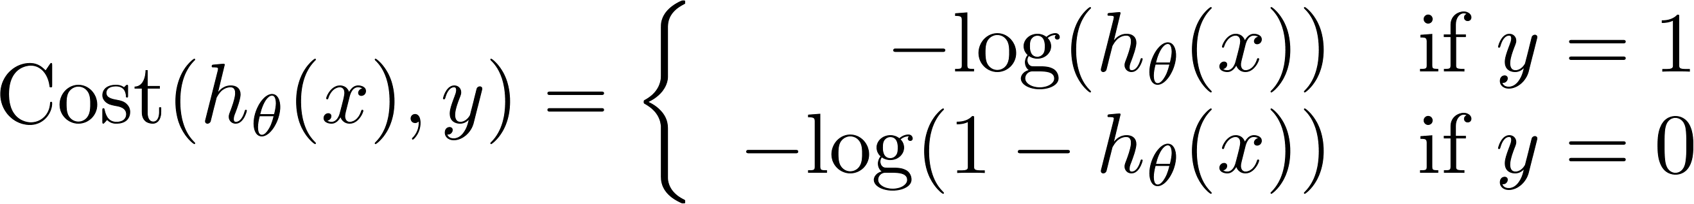

The Assumption that observations are independent, we can express likelihood function l(B|x) as product of individual terms.
l(B|x)= S(x) (1-S(x)) { do π i=1 to n }

Log likelihood L(B|x)=ln (l(B|x)) is computationally more tractable.
L(B|x) = y ln [ h_{θ} (x) ] + (1-y) ln [ 1- h_{θ} (x) ] { do Σ i=1 to n }

MLE estimators may be found by differentiating L(B|x) w.r.t each parameter and setting resulting forms equal to zero. `There are no closed form solutions for these differentiations available.
Mathematical Optimization:
Cost function is concave, so Gradient ascent (or any other optimization algorithm) is guaranteed to find the global maximum.

Logistic Cost function partial derivatives

∂j/∂θ J(θ) = 1/m Σ [h_{θ} (x) − y ] x { do Σ i=1 to m }
{repeat until convergence}

Note: m= number of observations

The above Equation for each instance it computes the prediction error and multiplies it by the feature value, and then it computes the average over all training instances. Once you have the gradient vector containing all the partial derivatives you can use it in the Batch Gradient ascent algorithm.

Application of Multiple logistic regression
In multiple logistic regression we use more than one predictor variable to classify the binary response variable. Let us see an example of how probabilities are calculated for an observation in the dataset using multiple logistic regression.
We may estimate that a particular customer may purchase given various values for the predicted variables. We will estimate the probabilities of purchase for a customer with the following attributes.

Gender 0 (Female=0)
OwnHome 1 (Rent=0)
Married 0 (Married=0)
Location 1 (Close=0)
Salary 99200
Children 0
Catalogs 24
Age_Old 0
Age_Middle 0

t = -0.20276261 + -0.01963491 (0) + -0.03286258(1) + -0.06697032 (0) + 0.40485854(1) + 1.20239816(99200) + -0.84388399 (0) + 0.28995397(24) + 0.1280475(0) + 0(0)

t = 119285
σ (t) = e^{t} / ( 1 + e^{t} )
σ (t) = 0.962794
Estimated probability that young customer who is female has rented a house and is married, also lives close to the location of the store, earning a salary of 99200, having no children and having taken 24 catalogs will purchase is 0.962794. Likewise, we calculate probability of purchase for all the customers.
Odds Ratio Interpretation example:
Gender | Female | Male | All
Purchase
0 | 310 | 223 | 533
1 | 196 | 271 | 467
All | 506 | 494 | 1000
Calculation:
( 271 / 223 ) / ( 196 / 310 ) = 1.922
The odds of purchasing for those who are male is only 1.92207 as large as the odds of purchasing for those who are female.
Evaluation Metrics:
Some of the evaluation metrics for classification problems that involve logistic regression are Accuracy, Lift/Gain chart, Concordance & Discordance.
Confusion Matrix:
Predicted: yes Predicted: No
Actual: yes [[125 35]
Actual: No [ 46 94]]
Sensitivity or Recall = TP / ( TP + FN ) = 0.78125
Precision = TP / TP + FP = 0.73099
Accuracy = ( (TP + TN) / n )* 100 = 0.73
Specificity = TN / (TN + FP) = 0.67
When yes is predicted how often it is correct, this is precision.
Among the actual yeses what fraction was predicted as yes, this is recall.
Among the actual no’s what fraction was predicted as no, also equal to 1 – false positive rate, this is specificity.
ROC and AUROC:
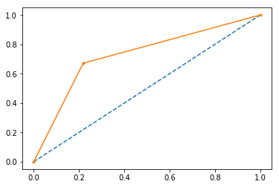
x-axis = False positive rate ; y-axis= True positive rate
Area under curve is utilized for setting the threshold of cut off probability to classify the predicted probability into various classes.
AUC : 0.7263392857142856
Concordance and Discordance:
Concordance = 0.53
Discordance = 0.47
Tied =0
Pairs= 22,400
Concordance > Discordance, which means the number of 1 value pairs have greater probabilities than 0 value pairs.
Cumulative Gain and Lift:
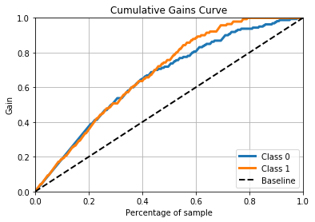
This graph tells you how well is your model segregating responders from non-responders. For example, the second decile however has 20% of the population, has 40% of responders. This means we have a 40% lift at second decile.
Lift curve is the plot between total lift and % population (on x). Note that for a random model, this always stays flat at 100%. Here is the plot for our case

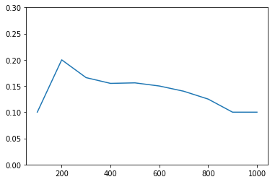
It tells you that our model does well till the 7th decile. Post which every decile will be skewed towards non-responders. Any model with lift at decile above 100% till minimum 2nd decile and maximum 8th decile is a good model.
Lift and Gain charts are widely used in campaign targeting problems. This tells us till which decile can we target customers for an specific campaign. Also, it tells you how much response do you expect from the new target base.

Final Results:
The following table shows us a set of customers who are highly likely to purchase, this is because we have sorted them in descending order of purchase probability. This table displays some of the customers of first decile.
Hence, we will be able to specifically target customers with marketing campaigns.

[Sample set of customers]
 | Gender | OwnHome | Married | Location | Salary | Children | Catalogs | Age_Old | Age_Middle | prob-1 | prob-2 | Actual | Pred
987 | 1 | 1 | 0 | 1 | 112900 | 0 | 24 | 1.0 | 0.0 | 0.016922 | 0.983078 | 1 | 1
14 | 0 | 1 | 0 | 1 | 110000 | 0 | 24 | 1.0 | 0.0 | 0.018177 | 0.981823 | 1 | 1
167 | 1 | 1 | 0 | 1 | 122100 | 0 | 12 | 0.0 | 0.0 | 0.027344 | 0.972656 | 1 | 1
386 | 1 | 1 | 0 | 0 | 123000 | 0 | 24 | 1.0 | 0.0 | 0.027577 | 0.972423 | 1 | 1
496 | 1 | 1 | 0 | 1 | 123000 | 1 | 24 | 0.0 | 0.0 | 0.034122 | 0.965878 | 1 | 1
993 | 0 | 1 | 0 | 1 | 99200 | 0 | 24 | 0.0 | 0.0 | 0.037206 | 0.962794 | 1 | 1
196 | 1 | 1 | 0 | 1 | 113800 | 0 | 12 | 0.0 | 0.0 | 0.037301 | 0.962699 | 0 | 1
141 | 0 | 1 | 0 | 1 | 100100 | 0 | 12 | 1.0 | 0.0 | 0.043988 | 0.956012 | 1 | 1
352 | 0 | 0 | 0 | 1 | 88400 | 0 | 18 | 1.0 | 0.0 | 0.049439 | 0.950561 | 1 | 1
45 | 0 | 1 | 0 | 0 | 111500 | 0 | 18 | 1.0 | 0.0 | 0.052465 | 0.947535 | 1 | 1
403 | 1 | 1 | 0 | 1 | 113300 | 1 | 18 | 0.0 | 0.0 | 0.062721 | 0.937279 | 1 | 1
736 | 1 | 0 | 0 | 0 | 118800 | 0 | 12 | 0.0 | 0.0 | 0.067852 | 0.932148 | 1 | 1
142 | 1 | 1 | 0 | 1 | 103700 | 1 | 24 | 0.0 | 0.0 | 0.069327 | 0.930673 | 1 | 1
523 | 0 | 0 | 0 | 1 | 72200 | 0 | 24 | 1.0 | 0.0 | 0.069526 | 0.930474 | 1 | 1
215 | 0 | 1 | 0 | 1 | 101700 | 1 | 24 | 0.0 | 0.0 | 0.071821 | 0.928179 | 0 | 1
876 | 1 | 1 | 0 | 0 | 116100 | 1 | 24 | 1.0 | 0.0 | 0.075498 | 0.924502 | 1 | 1
462 | 1 | 1 | 0 | 0 | 108900 | 0 | 12 | 1.0 | 0.0 | 0.076557 | 0.923443 | 1 | 1
200 | 1 | 1 | 0 | 1 | 100100 | 1 | 24 | 0.0 | 0.0 | 0.078861 | 0.921139 | 1 | 1
984 | 1 | 0 | 0 | 1 | 66200 | 0 | 24 | 1.0 | 0.0 | 0.089252 | 0.910748 | 1 | 1
351 | 0 | 1 | 0 | 0 | 97900 | 0 | 24 | 0.0 | 0.0 | 0.090014 | 0.909986 | 1 | 1
814 | 1 | 1 | 0 | 0 | 90600 | 0 | 24 | 1.0 | 0.0 | 0.090262 | 0.909738 | 1 | 1
989 | 1 | 1 | 0 | 1 | 102700 | 1 | 18 | 0.0 | 0.0 | 0.091574 | 0.908426 | 1 | 1
864 | 1 | 1 | 1 | 1 | 75400 | 0 | 24 | 0.0 | 0.0 | 0.103382 | 0.896618 | 1 | 1
413 | 1 | 1 | 0 | 1 | 62300 | 0 | 24 | 1.0 | 0.0 | 0.108495 | 0.891505 | 1 | 1
315 | 1 | 1 | 0 | 0 | 84300 | 0 | 24 | 1.0 | 0.0 | 0.112353 | 0.887647 | 1 | 1
27 | 0 | 0 | 0 | 1 | 72900 | 0 | 18 | 0.0 | 0.0 | 0.115192 | 0.884808 | 1 | 1
745 | 1 | 1 | 0 | 1 | 75500 | 0 | 18 | 0.0 | 0.0 | 0.115664 | 0.884336 | 0 | 1
535 | 1 | 1 | 0 | 0 | 90300 | 0 | 24 | 0.0 | 0.0 | 0.121274 | 0.878726 | 1 | 1
267 | 1 | 1 | 1 | 1 | 62000 | 0 | 24 | 1.0 | 0.0 | 0.123395 | 0.876605 | 1 | 1

References
[1] Data mining and predictive analytics by Daniel T. Laros

[2] Aurélien Géron-Hands-on Machine Learning with Scikit-Learn and TensorFlow-O’Reilly

